- Trigometric ratios 3

1. Complete the table below by filling in the blank spaces.

X⁰ | 0⁰ | 30⁰ | 60⁰ | 90⁰ | 120⁰ | 150⁰ | 180⁰ | 210⁰ | 240⁰ | 270⁰ | 300⁰ | 330⁰ | 360⁰
Cos x | 1.00 |  | 0.50 |  |  | -0.87 |  | -0.87
2cos½x | 2.00 | 1.93 |  |  |  |  | 0.50
(2mks)
On the grid provided, using a scale of 1 cm to represent 30⁰ on the horizontal axis and 4cm to represent 1 unit on the vertical axis draw the graph of y = cos x⁰ and y = 2 cos ½ x⁰. (4mks)
(a) State the period and amplitude of y = 2 cos ½ x⁰ (2mks)
(b) Use your graph to solve the equation 2 cos ½ x – cos x = 0. (2mks)
2. a) Complete the table below by filling in the blank spaces
x | -90 | -75 | -60 | -45 | -30 | -15 |  | 15 | 30 | 45 | 60 | 75 | 90
3cos2x-1 | -40 | -3.6 |  | -1.0 | 0.5 | 1.6 |  | 1.6 | 0.5 |  | -2.5 | -3.6 | -4.0
2sin (2x+30) | -1.0 | -1.73 |  | -1.73 | -1.0 | 0 |  | 1.73 | 2.0 |  | 1.0 | 0 | -1.0
- On the grid provided, draw on the same set of axes the graphs of 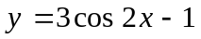and 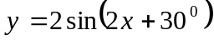for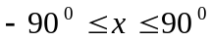. Using a scale o 1 cm for 15⁰ on axis and 2 cm for I unit on the y-axis (5mks)
- State the period of (1mk)
- Solve the equation 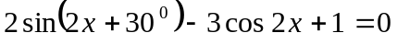 (2mks)
3. Complete the table below by filling in the blank spaces.

x° | 0° | 30° | 60° | 90° | 120° | 150° | 180° | 210° | 240° | 270° | 300° | 330° | 360°
Cos x | 1.00 |  | 0.5 |  |  | -0.87° |  | -0.87°
2 cos ½ x° | 2.00 | 1.93 |  |  |  | 0.52 |  |  | -1.00 |  |  |  | -2.00

Using the scale 1 cm to represent 30º on the horizontal axis and 4cm to represent 1 unit on the vertical axis, draw on the grid provided, the graph of y = cos x° and y = 2 cos ½ x°
a) Find the period and amplitude of y = 2cos ½ x° (2mks)
b) Describe the transformation that maps the graph of y = Cos x° on the graph of
y = 2 cos ½ x°. (2mks)

4. The table below gives some values of y = sin 2x and y = 2 cox is the range given.
(a) Complete

Xº | -225 | -180 | -135 | -90 | -45 | 0 | 45 | 90 | 135 | 180 | 225
y – sin 2x³ | -1.0 |  | 1.0 |  |  | 0 |  |  | -1.0 |  | 1.0
y = 2cos x³ | -1.4 |  | -1.4 |  |  | 2.0 |  |  | -1.4 |  | -1.4

(b) On the same axes, draw the graphs of y = sin 2x and y = 2 cos x.
(c) Use your graph to find in values of x for which sin 2x – 2 cos x = 0.
(d) From your graph
(i) Find the highest point of graph y = sin 2x.
(ii) The lowest point of graph y = 2 cos x.

5. (a) Copy and complete the table below for y =2sin (x +15)º and y =cos(2x -30)º for 0º ≤ x ≤ 360º

x | 0 | 30 | 60 | 90 | 120 | 150 | 180 | 210 | 240 | 270 | 300
y =2sin(x+15)
y= cos(2x-30)
(b) On the same axis draw the graphs:
y = 2sin (x + 15) and y = cos(2x -30) for 0º ≤ x ≤ 360º
(c) Use your graph to:
(i) State the amplitudes of the functions y = 2sin (x +15) and y= cos (2x -30)
(ii) Solve the equation 2sin (x+15) – cos (2x -30) = 0
6. The diagram below shows a frustum of a square based pyramid. The base ABCD is a
square of side 10cm. The top A¹B¹C¹D¹ is a square of side 4cm and each of the slant edges
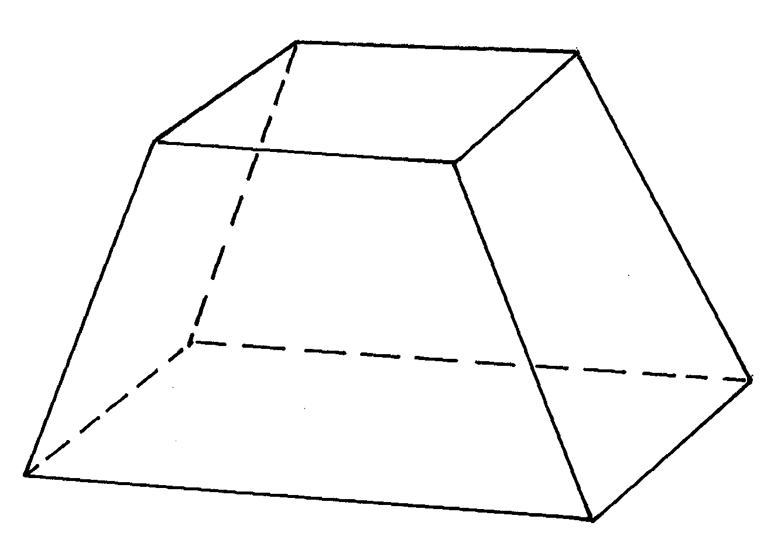
of the frustum is 5cm
4cm
10cm
10cm
5cm
4cm
D¹
A¹
C¹
C
B
A
D

Determine the:
i) Altitude of the frustrum
ii) Angle between AC1 and the base ABCD
iii) Calculate the volume of the frustrum

7. (a) Compete the table below:
y = 3sin (2x + 15) º

x | -180 | -150 | -120 | -90 | -60 | -30 | 0 | 30 | 60 | 90 | 120
y | 0.8 |  |  | -0.8 |  |  | 0.8 |  | 21

(b) Use the table to draw the curve y = 3sin (2x +15) for the values – 180º≤ θ ≤120º
(c) Use the graph to find:
(i) The amplitude
(ii) The period
(iii) The solution to the equation:-
Sin (2x + 15)º = ¹/₃

8. Make q the subject of the formula in A
P + 3q
q – 3p

=

B

9. a) Complete the table below for the functions y = cos (2x + 45)º and y = -sin (x + 30º)for
- 180º ≤ x ≤ 180º.

 | -180 | -150 | -120 | -90 | -60 | -30 | 0 | 30 | 60 | 90 | 120 | 150 | 180
y=Cos(2x + 45º) | 0.71 |  | -0.97 | -0.71 |  |  | 0.71 |  | -0.97 |  |  | 0.97
y = -sin(x + 30º) | 0.5 | 0.87 |  |  | 0.5 |  |  | -0.87 |  | -0.87 |  |  | 0.5

b) On the same axis, draw the graphs of y = cos (2x + 45)º and y = -sin (x + 30)º
c) Use the graphs drawn in (b) above to solve the equation.

Cos (2x + 45)º + sin(x + 30)º = 0

10. Without using tables or calculators evaluate sin 60º cos 60º leaving your answer in surd form. tan 30º sin 45º
11. (a) Complete the table below for the functions y = 3 sin x and y = 2 cos x
X | 0 | 30 | 60 | 90 | 120 | 150 | 180 | 210 | 240 | 270 | 300 | 330 | 360
3sin x |  |  | 2.6 | 3 |  |  | 0 | -1.5 | -2.6 | -3 |  | -1.5
2cosx |  | 1.7 | 1.0 |  |  | -1.7 | -2 | -1.0 |  |  | 1.0 | 1.7 | 2
(b) Using a scale of 2cm to represent 1 unit on the y- axis and 1cm to present 30º on the
x-axis ,draw the graphs of y =3sinx and y = 2cosx on the same axes on the grid provided
(c) From your graphs:
(i) State the amplitude of y = 3sin x
(ii) Find the values of x for which 3sin x – 2cos x = 0
(iii) Find the range of values of x for which 3sin x ≥ 2cos x

12. (a) Fill in the following table of the given function:-

x | 0 | 90 | 180 | 270 | 360 | 450 | 540 | 630 | 720 | 810
sin ½x | 0 |  |  | 0.71 |  |  |  |  | 0
3Sin (½x + 60) |  |  |  |  | -2.6 |  |  |  |  | 2.6

(b) On the grid provided draw the graph of the function y = sin ½x and y = 3Sin (½x + 60)
on the same set of axes
(c) What transformation would map the function y = sin ½ x onto y = 3 Sin (½ x + 60)
(d) (i) State the period and amplitude of function : y = 3 Sin (½x + 60
(ii) Use your graph to solve the equation: 3Sin ( ½x + 60) – Sin ½x = 0
13. a) Complete the table below giving your answer to 2 decimal places

xº | 0º | 30º | 60º | 90º | 120º | 150º | 180º
2sinxº | 0 | 1 |  | 2
1 – Cos xº |  |  | 0.50 | 1 |  |  | 2

b) On the grid provided, using the same axis and scale draw the graphs of :-
y = 2sinxº, and y =1-cosx for
0º≤ x ≤ 180º , take the scale of
2cm for 30º on the x-axis
2cm for 1 unit on the y-axis
c) use the graph in (b)above too solve the equation 2sinx + cosxº = 1 and determine the
range of values of for which 2 sinxº =1-cosxº

14. Solve the equation 2 sin (x + 30) = 1 for 0 ≤ x ≤ 360.

15. (a) Complete the table below, giving your values correct to 1 decimal place

x | 0º | 10º | 20º | 30º | 40º | 50º | 60º | 70º | 80º | 90º | 100º | 110º | 120º | 130º | 140º | 150º | 160º | 170º | 180º
10 sin x | 0 | - | 3.4 | 5.0 |  | 7.7 |  | 9.4 | 9.8 | 10 | 9.8 | 9.4 |  | 7.7 |  | 5.0 | 3.4 |  | 0

(b) Draw a graph of y = 10 sin x for values of x from 0º to 180º. Take the scale 2cm represents
20º on the x-axis and 1cm represents 1 unit on the y axis
(c) By drawing a suitable straight line on the same axis, solve the equation: -
500 sin x = -x + 250

16. Complete the table below for the functions y = cosx and y =2 cos (x 300) for θ≤x ≤ 3600

x | 0º | 30º | 60º | 90º | 120º | 150º | 180º | 210º | 240º | 270º | 300º | 330º | 360º
Cos x | 1 | 0.87 | 0.5 |  | -0.5 | -0.87 | -1.0 |  | 0.5 | 0 |  | 0.87 | 1
2 cos (x + 30º) | 1.73 |  | 0 | -1.0 |  | -2.0 | -1.73 | -1.0 |  | 1 | 1.73 | 2.00 | 1.73

(a) On the same axis, draw the graphs of y cos x and y 2cos(x - 30) for O<x < 360°.
(b) (i) State the amplitude of the graph y = cos xº.
(ii) State the period of the graph y = 2 cos (x + 30°).
c) Use your graph to solve
Cos x = 2cos(x+30°)

17. Solve the equation sin(2θ +10) = -0.5
for 0 ≤ θ ≤ 2π^{c}

18. Solve the equation
4 sin 2x = 5 – 4 cos² x for 0° ≤ x ≤ 360°

19. (a) Complete the table given below by filling in the blank spaces

X | 0 | 15 | 30 | 45 | 60 | 75 | 90 | 105 | 120 | 135 | 150 | 165 | 870
4cos 2x | 4.00 |  | 2.00 | 0 | -2.00 | -3.46 | -4.00 | -3.46 | -2.00 | 0 | 2.00 |  | 4.00
2 sin (2x +30º ) | 1.00 | 1.73 | 2.00 | 1.73 |  | 0 | -1.00 | -1.73 | -2.00 | -1.73 |  | 0 | 1.00

(b) On the grid provided; draw on the same axes, the graphs of y = 4cos 2x and
y =2sin(2x +30º) for 0º ≤ _{X} ≤ 180º. Take the scale: 1cm for 15º on the x-axis and
2cm for 1unit on the y-axis
(c) From your graph:-
(i) State the amplitude of y = cos 2x
(ii) Find the period of y = 2sin (2x + 30º)
(d) Use your graph to solve:-
4cos2x – 2sin (2x +30) = 0

